Filters

Purpose: The objective of this activity is for the students to explore simple filters.

Overview: Just think how many radio and television stations there are in your local area. Now multiply that number by the tens of thousands and you will just begin to approach the number of radio stations and signals there are in on the air at any given moment. The students may have built and listened to a simple crystal radio set and have experienced firsthand the interference cause by radio stations that occupy similar frequency channels. So what can you do to eliminated some of the interfering or competing signals? You filter the unwanted signal out of the picture.
During this activity the students will explore another basic building block of electronics, the filter. There are three basic types of filters: those that pass frequencies higher than the design frequency (high-pass), those that pass frequencies lower than the design frequency (low-pass), and those that pass a desired range of frequencies (band-pass). Pass means that the frequency waves pass through the filter without being appreciably degraded or reduced in amplitude while undesirable frequencies are significantly reduced in strength.
Within the typical wireless device, numerous frequencies are created, combined, and separated to achieve the desired outcome. Filters are critical to this process so that only the desired frequencies or signals are passed from one section of the device to the next.
External filters are often employed outside of the wireless device to reduce harmful interference. Television signals are relatively high in frequencies (VHF and UHF) and are sometimes interfered by lower frequency signals. To help alleviate the problem, a high-pass filter can be installed between the antenna and the TV. The high-pass filter will pass the desirable higher frequency TV signals while attenuating (reducing) the interfering lower frequency signals. On the lower frequency transmitter side, a low-pass filter can be installed between the transmitter and the antenna to pass the desirable lower frequencies but attenuate the higher frequencies that are causing the interference.
In this activity, a simple active band pass filter circuit will be used to demonstrate the concept of the filter. Using the variable frequency oscillator on the demonstration board as a signal source, students will be able to observe on the oscilloscope the attenuation of out-of-pass-band frequencies while the in-band frequencies are passed relatively intact.

Time: Fifteen minutes to set up the demonstration board and the oscilloscope. One class period to demonstrate the fundamentals of filters.

Skills Required:

- Listening
- Observation
- Critical thinking
- Writing and expression

Materials and Tools:

- The demonstration board
- Oscilloscope

Preparation:

- Review with the students the properties of AC current (see background materials).

- Review with the students the vocabulary needed to describe a waveform (wavelength, frequency, cycle, crests, trough, positive side, negative side, and amplitude).

- Review with the students the relationship between amplitude and the strength of the wave.

- Review with the students the concept of interference and how competing radio waves can make the transfer of information virtually impossible.

- Review with the students how they use filters in their daily lives to reduce or eliminate competing signals that interfere with what they are doing (headphones, plugging one ear while on the telephone, closing the door for privacy, increasing the volume over the din of voices in the room to hear the stereo, closing the car window during their favorite song, tells a friend to be quiet during an important song or message, “cranking” up the base on the stereo, etc.)

Background:

Now You’re Talking pages 7.4.

ARRL Handbook pages 8.6.

What to do and how to do it:

- Connect one channel of the oscilloscope to the output of a variable frequency oscillator (VFO) on the activity board. Connect the output of the VFO to the input of the band pass filter. Task the students to note the peak voltage of the waveform produced by the oscillator.

- Connect the second channel of the oscilloscope to the output of the filter. Task students to note the peak voltage of the waveform on the output of the filter. They should also note the wave shape and frequency of the output waveform. Figure 1 depicts the oscilloscope display. Note the set up of the probes, where the cursors are set to measure frequency, and the location of the frequency and amplitude data on the tables.

- Sweep the VFO through the frequency range and note the change in signal amplitude for both the input and output of the filter. The amplitude of the input signal should stay relatively stable while the amplitude of the output signal should increase, peak, and decrease as the frequency sweeps though the pass band of the filter. The graphs in the remaining figures are snapshots of the oscilloscope display as the frequency is changed from low to high frequency. While the frequency is being swept across the pass band, it is a good time to note the relationship between frequency, wavelength and amplitude.

- Now step through the frequencies at small intervals (approximately 50 Hz) and note the frequency and signal peak-to-peak amplitude on the filter output. This data is recorded for exploration in a spreadsheet or for plotting on a graph.

- The peak frequency (the output frequency that has the highest amplitude) should be readily apparent by watching the oscilloscope pattern. Slowly adjust the VFO for this peak amplitude and note the frequency and amplitude for inclusion of this specific point in the data table.

- The students should either plot the data on a graph or use an Excel Spreadsheet to analyze the data and produce a plot of the filter pass band as in attached figures.

Data Analysis:

- Assign students to compare the input to the output waveforms in their journals (compare frequency, wavelength, and amplitude) as the frequency of the VFO changed.

- Assign the students to calculate the (negative) gain, or amount of de-amplification, that was achieved by the filter at each frequency.

- Task the students to create a graph of the data collected while using the variable frequency oscillator. The Y-axis of the graph would be the amplitude of the wave at each frequency. The X-axis of the graph would be the frequency of the wave.

Activity questions:

- Do you have filters in your home? If so, why?

- Did you see any change in the waveform from the input compared to the output as the frequency of the VFO was changed? Use the vocabulary of AC waves to make your comparison.

- How did you calculate the negative gain of the filter? What does negative gain mean in plain English? What other component of the waveform must you use when describing the performance of a filter?

- From the graph you created using the variable frequency oscillator, can you determine what type of filter was being used? What is the approximate center frequency of the filter? How might this type of filter be used to improve your home stereo system?

- Do you think there is a limit to the amount of filtering possible? If so, what would cause that limit?

- What happens if you turn your bass filter at home too high? Are there any precautions that you should be aware of when using a lot of bass in your home stereo system?

- Many communities have, or are contemplating, city ordinances restricting the use of amplifiers in automobiles. Do filters have anything to do with how automobile stereos are typically operated? Could the use of filters make the car stereo more objectionable to some citizens?

- Pretend you live near the neighborhood fire department. Every time the firefighters use their radios you can hear the call through your stereo and it really bothers you. After what you have learned, what are some things you could do to reduce the interference?

Adaptations for special needs: There may be substantial accommodations required for this activity depending on the need. Hearing impaired students will be able to detect amplitude changes by touching a speaker connected first at the oscillator and then to the amplifier output. Visually impaired students may need a tactile manipulative that simulates the sine wave form displayed on the oscilloscope. Tactile waveforms with various wavelengths prepared before the class period can be made out of corkboard with push pins and rubber bands or yarn. The pushpins are placed at points along the sine wave plot and the rubber bands or yarn are formed along the points of the plot.

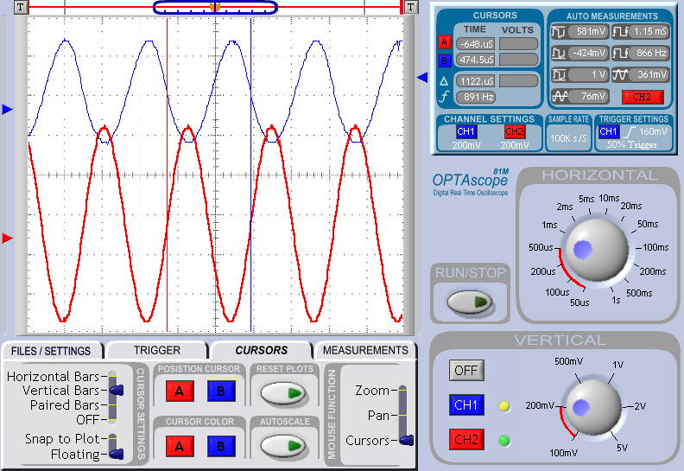
Frequency Readout
Peak-to-Peak Voltage (mV)
Figure 1.

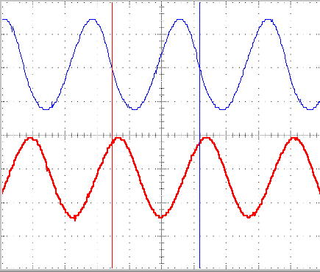
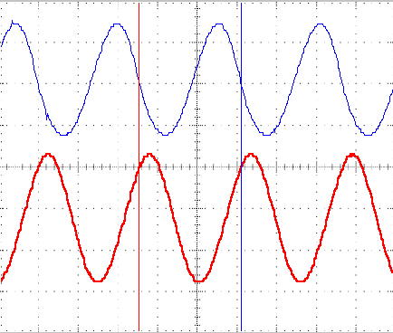
726Hz
765Hz

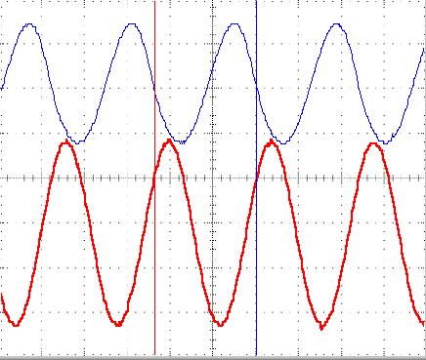
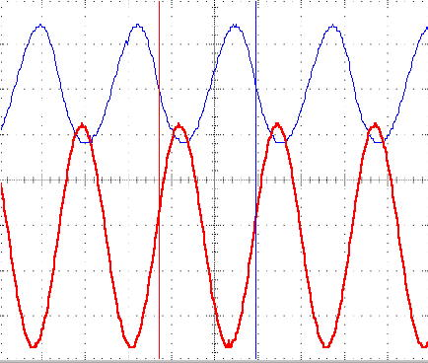
831Hz
861Hz

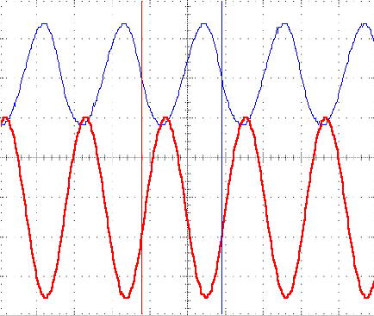
881Hz
931Hz

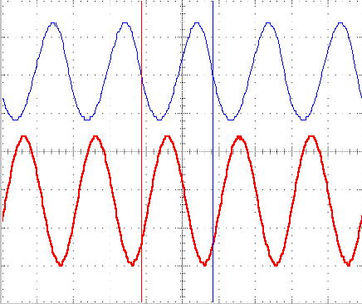
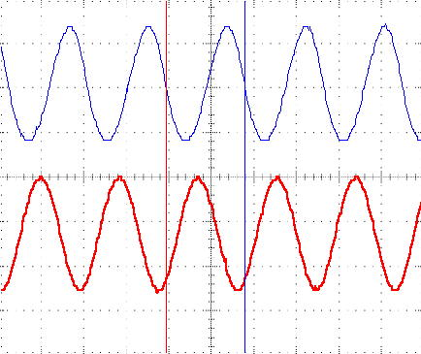
1000Hz
1060Hz

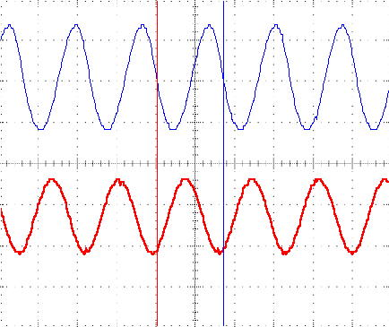
1160Hz

Bandpass Filter Activity
Data
Frequency (Hz) |  | Peak to Peak Voltage (mV)
726 |  | 518
765 |  | 628
831 |  | 879
881 |  | 1020
930 |  | 926
1000 |  | 722
1060 |  | 533
1160 |  | 392

